New Member Onboarding
Mockup Screen Reference
Pending Approval • Step 3: Profile Completion
This document provides a detailed written description of the ROCA New Member Onboarding mockup screens for Batch 2 of the 7-step onboarding wizard. It covers the Pending Approval waiting state (shown when admin review is required) and Step 3: Profile Completion (shown once the member is approved). It serves as a reference companion to the visual mockup image, documenting the purpose, layout, and interaction design of each panel for the benefit of engineers, QA, and stakeholders.

1. Onboarding Screens Mockup — Batch 2
The mockup below renders two screens of the ROCA onboarding wizard side by side, as they appear on a desktop web browser. The left panel shows the Pending Approval waiting state (reached when an organization requires manual admin review of join requests). The right panel shows Step 3: Profile Completion (the first step a member completes after being approved). Both screens share the consistent ROCA header, liturgical season banner, and the 7-step progress indicator.
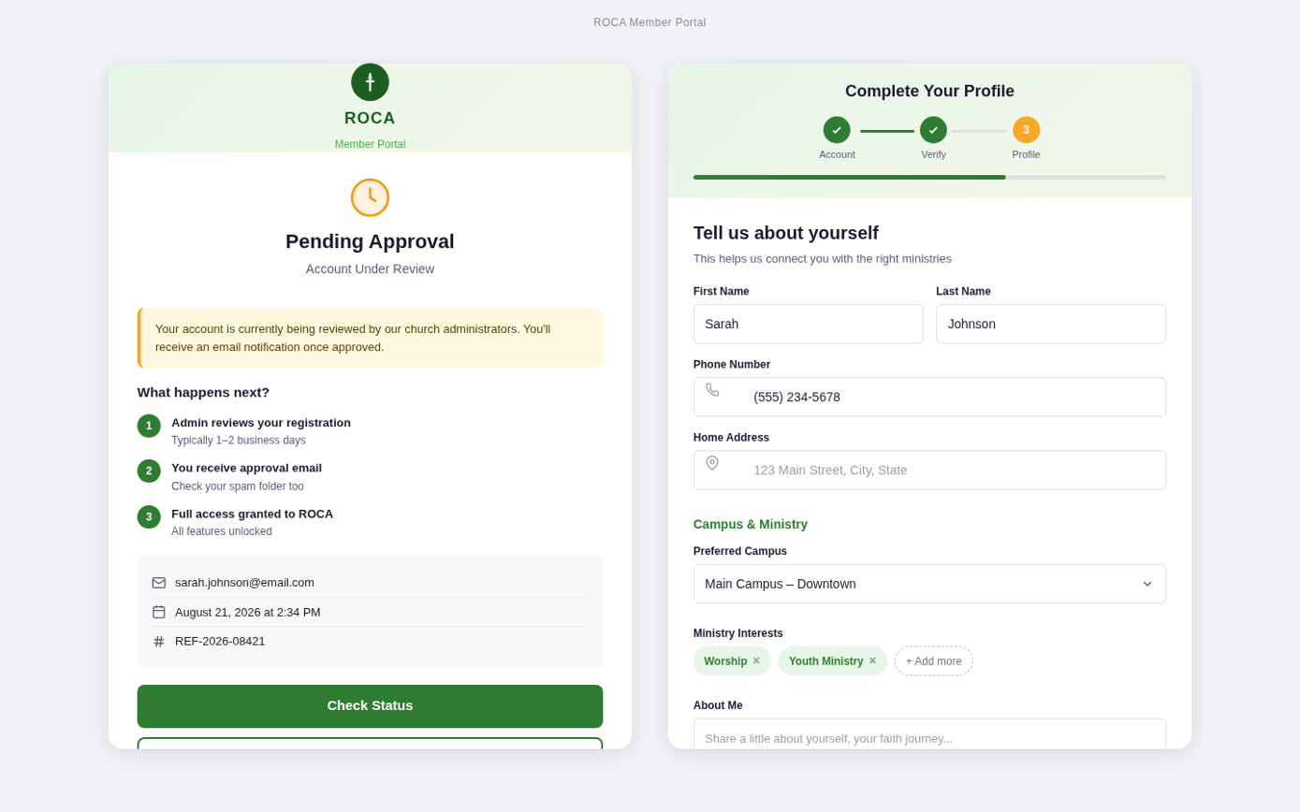
Figure 1 — ROCA New Member Onboarding: Pending Approval state (left) and Step 3: Profile Completion (right)

2. Left Panel — Pending Approval State
The Pending Approval screen is a conditional waiting state displayed when a new member has submitted a join request to an organization that requires manual admin review. Rather than leaving the member in a dead-end state, this screen reassures them that their request is in progress, sets clear timeline expectations, and keeps them engaged by surfacing public events they can browse while waiting.
2.1 Purpose & Goals
- Primary goal: Communicate approval status clearly without causing anxiety or confusion.
- Secondary goal: Maintain engagement by offering access to public content (event calendar) while the request is reviewed.
- Tone: Warm and expectant — this should feel like receiving a warm handshake at the door, not a bureaucratic rejection queue.
- Trust signal: Confirmation that the member's email address was recorded correctly and that a notification will be sent.
2.2 Screen Layout
The Pending Approval screen reuses the ROCA global header, liturgical season banner, and 7-step progress indicator from the rest of the onboarding wizard. The progress bar reflects the member's current status: Steps 1 and 2 show as completed (green checkmark pills), while Steps 3-7 remain grayed out to indicate they are locked pending approval. The card content is vertically stacked and centered, with ample whitespace to avoid a cluttered or alarming appearance.
2.3 Layout Zones
Zone | Content Description
Status Icon | An amber/orange hourglass or clock icon (48px) centered at the top of the card, visually signaling a waiting state without alarm. The amber color distinguishes this state from error (red) and success (green).
Headline | "You're on your way!" — H1 heading in the primary dark green (#1B4332). Subtitle line: "Your request to join [Church Name] is under review." Both lines are centered.
Confirmation Block | Muted-color text block confirming: "You'll receive an email at [member@email.com] when your account is approved (usually within 24 hours)." The email address is rendered in bold to confirm it was captured correctly.
Public Events Preview | A section headed "In the meantime, explore public events:" followed by 2-3 upcoming public event cards. Each card shows: category color dot, event name, date, time, and location. Clicking a card opens the public event detail view. This keeps the member engaged and gives them a first taste of the platform.
Action Buttons | Two secondary action buttons: [View Public Calendar] (ghost/outlined style, navigates to the public-facing calendar view) and [Resend Confirmation Email] (text link style, triggers a re-send of the welcome/verification email). These are peer-level, neither should dominate.
Progress Steps 3-7 | Steps 3-7 in the progress indicator are rendered as grey outlined pills (not filled, no numbers lit), communicating that they are locked and will become accessible after approval. This visual state is intentional — it sets expectations without implying the member has made an error.
2.4 State Transitions
- Admin approves request: System updates member.onboarding_status to APPROVED, sends push + email notification to the member with a deep link to resume at Step 3. The pending screen is replaced by Step 3 on the member's next app load.
- Admin rejects request: System sets status to APPROVAL_REJECTED, sends email with provided reason. Member sees a rejection message and is invited to contact the church admin.
- Timeout (48 hours with no admin action): System sends a reminder notification to all org admins and pastors.
- Member closes browser: Progress is saved. Returning to the app shows the same Pending Approval screen until the request is resolved.
2.5 Design Notes
Keeping Members Engaged During Approval
The public events preview is a critical engagement feature. Members who browse public events during the approval window are significantly more likely to complete onboarding after approval compared to members who close the app and wait passively.
Event cards shown on this screen are filtered to visibility = "public" only — no members-only content is surfaced before approval.
The "View Public Calendar" CTA opens a read-only calendar view. No RSVP or registration actions are available until the member is fully approved.

Approval Flow Design Philosophy
The pending screen is shown only when the organization has approval_required = true in its configuration. Organizations with open_registration = true skip this screen entirely — members are auto-approved and proceed directly to Step 3 without interruption.
The distinction between these two paths is invisible to the member. They experience the same first two steps regardless; only the transition behavior differs.
Admins can pre-configure their org to use open registration for low-friction onboarding (e.g., for a public event or outreach), or require approval for tighter community management.

3. Right Panel — Step 3: Profile Completion
Step 3 is the first screen a member completes after their account is approved. It collects supplementary profile information — contact details, family composition, and accessibility preferences — that enables the platform to personalize event recommendations and connect members to appropriate ministries. All fields on this screen are optional; members can skip and complete them at any time from their profile settings.
3.1 Purpose & Goals
- Primary action: Enrich the member's profile with contact info, family details, and accessibility preferences.
- Personalization impact: Phone number enables SMS notifications; family/children info enables childcare event filtering; accessibility preferences apply as default calendar filters.
- Photo upload: Profile photo upload is offered here (if skipped in Step 1) via a drag-and-drop zone with camera capture fallback on mobile.
- Skip-friendly: A "Skip for now" CTA is equally prominent alongside "Continue" — this step must not feel mandatory.
3.2 Screen Layout
Step 3 shares the wizard card layout from Steps 1 and 2. The progress indicator shows Steps 1 and 2 as completed checkmarks, with Step 3 highlighted as the active pill. Steps 4-7 remain as grey outlined pills. The card content scrolls vertically (if needed) and does not paginate. The two-button navigation row (Back, Skip / Continue) is pinned to the bottom of the card on desktop and to the bottom of the viewport on mobile.
3.3 Layout Zones
Zone | Content Description
Section Headline | "Tell us a little about yourself" — friendly H1 in dark green. Subtitle: "All fields are optional and can be updated any time." This framing is essential to reducing form abandonment on this step.
Phone + DOB Row | Two-column layout: Phone Number field (left, with country code picker) and Date of Birth field (right, MM/DD/YYYY format picker). Both are optional. Phone accepts E.164 format; validation fires on blur. DOB is used for age-appropriate group recommendations only — never displayed publicly.
Profile Photo Zone | Drag-and-drop upload zone with a dashed border and a camera icon. Label: "Upload a profile photo (optional)." Supported formats: JPG, PNG, HEIC. Max 10 MB. On mobile, tapping this zone opens the native image picker with camera + library options. Shows a live preview thumbnail after selection. If already uploaded in Step 1, this zone shows the existing photo with an "Edit" overlay.
Family / Household Builder | An expandable household section that lets the member add family members to their account. Rows are shown for: self (read-only — shown as "[Name] (you)" with a badge), spouse/partner (name field), and children (name + grade-level dropdown per child).  A "[+ Add family member]" link appends a new row. Adding a child automatically sets has_children = true on the member record, enabling childcare filtering in the event calendar.
Accessibility Preferences | A group of three checkboxes: "Show wheelchair-accessible events only", "Show events with childcare availability", and "Require livestream option." These are saved as JSONB fields in the member's accessibility_prefs column and applied as default filters across all calendar and event discovery views.
Contact Preference | A radio group for preferred contact method: Email (default), SMS, or Both. The selected value seeds the notification_preferences record created in Step 6. This prevents members from being caught off-guard by SMS messages they didn't expect.
Navigation Buttons | Three-button row: [<- Back] text link (left), [Skip for now] outlined button (center), [Continue ->] filled green CTA (right). The "Continue" and "Skip" buttons have equal visual weight — neither should feel like the "wrong" choice.
3.4 Field Validation & Save Behavior
- Phone number: Optional. If provided, validated against E.164 format on blur. Invalid number shows inline error but does not block form submission.
- Date of birth: Optional. Must be a valid past date. The picker prevents future dates. Min age: 13 (COPPA compliance).
- Profile photo: Resized to 400×400px and converted to JPEG before upload to S3 at /avatars/{member_id}.jpg. Original file is not retained.
- Family members: Children's names are stored as-is. Grade level is a string enum (Pre-K, K, 1st through 12th, College+). No additional validation.
- Auto-save: The wizard Zustand store writes all field values to local storage on every change. Data is not submitted to the API until the member clicks "Continue" or "Skip."
- Skip behavior: Clicking "Skip for now" advances to Step 4 without calling any profile update APIs. The member's onboarding_step is incremented to 4. Profile fields remain blank.
3.5 Interactions & Navigation
- [<- Back]: Returns to Step 2 (Organization Discovery). All entered data is preserved in the Zustand store.
- [Skip for now]: Advances to Step 4 (Interests & Groups). Member's onboarding_status is set to ONBOARDING_INCOMPLETE. A "Complete your profile" nudge banner appears on the dashboard for 14 days.
- [Continue ->]: Calls PUT /members/me/profile with all entered field values. On success, advances to Step 4. On API error, shows an inline error toast and keeps the member on Step 3.
- Photo upload: Fires independently of the main form CTA. The upload is triggered immediately when a file is selected (not on Continue click), using a presigned S3 URL. Upload progress is shown inline.
3.6 Design Notes
Privacy-First Framing
Date of birth and phone number are sensitive fields. The form uses helper text beneath each field to explain how the data is used:
"Birthday" — helper text: "Used for age-appropriate group recommendations. Never shared publicly."
"Phone" — helper text: "For SMS notifications only, if you choose SMS in Step 6."
This transparency reduces form abandonment and builds trust at a critical moment in the relationship.

Mobile Adaptations for Step 3
The Phone + DOB two-column row stacks vertically on mobile (≤768px), with Phone above DOB.
The photo upload zone increases to full-width and 120px tall on mobile for accessibility.
Family member rows include a swipe-to-delete gesture (left swipe reveals a red delete button) on mobile.
The three-button navigation row stacks on small screens: Continue (full-width, green) on top, Skip below (full-width, outlined), Back as a text link below that.

4. Shared UI Elements (Both Screens)
4.1 7-Step Progress Indicator
- Displayed as a horizontal row of 7 pill-shaped step indicators at the top of the wizard card.
- Completed steps: filled green pill with a white checkmark (✓) icon.
- Active step: filled dark green pill with white step number; slightly larger than inactive pills.
- Upcoming steps: outlined grey pills with step numbers.
- Locked steps (Pending Approval state): outlined grey pills with a small padlock icon instead of a number.
- On mobile, step labels (text) are hidden; only numbers and icons are shown to conserve horizontal space.
- The indicator is non-interactive — users cannot click ahead to skip steps; they must use the wizard navigation buttons.
4.2 Liturgical Season Banner
- Displayed as a full-width colored strip between the global header and the card.
- Content: a small season icon, season name, and current week number (e.g., "Ordinary Time • Week 21").
- Color is driven by the active liturgical season: green for Ordinary Time, purple for Advent/Lent, gold for Christmas/Easter, red for Holy Week/Pentecost.
- This banner is identical to the one displayed throughout the main application, establishing visual continuity from first contact.
4.3 Mobile Adaptations
- Both screens stack to full-width single-column layouts on mobile viewports (≤768px).
- Navigation buttons (Back, Skip, Continue) are pinned to the bottom of the viewport as a sticky action bar.
- Public event cards on the Pending Approval screen stack vertically on mobile with increased tap target height.
- The family builder section on Step 3 shows a collapsed summary (e.g., "2 family members added") on mobile with a tap-to-expand gesture.

5. Screen Transitions
The transitions between these screens follow the same animation system as the rest of the onboarding wizard. All step-to-step transitions use a horizontal slide (250ms ease-in-out): the exiting screen slides out to the left, the entering screen slides in from the right. The progress indicator updates in sync with the slide animation. On mobile (React Native), this is implemented as a pager swipe using the React Native Pager View component.
Trigger | System Action | User Feedback
Admin approves join request | PUT /admin/join-requests/:id; member.status = APPROVED; deep link sent | Member receives push + email; next app open loads Step 3 directly
[Continue ->] on Step 3 | PUT /members/me/profile called with form data; onboarding_step = 4 | Loading spinner on CTA; slide animation to Step 4 on success
[Skip for now] on Step 3 | No profile API call; onboarding_step = 4; onboarding_status = ONBOARDING_INCOMPLETE | Immediate slide to Step 4; dashboard will show "Complete profile" nudge
[<- Back] on Step 3 | onboarding_step = 2; local store preserved | Reverse slide animation; Step 2 content restored from Zustand store

6. Related Document References
Document | Reference Content
ROCA New Member Onboarding Design Document | Full onboarding user flow specification including all 7 steps, user stories (US-1 through US-10), implementation architecture, and testing strategy.
ROCA Onboarding Mockup — Batch 1 (Steps 1 & 2) | Companion screen description document for the Account Creation (Step 1) and Organization Discovery (Step 2) screens.
ROCA Unified Technical Design Specification | Complete application architecture, 15-table database schema, 75+ API endpoints, RBAC permission matrix, and infrastructure design.
ROCA Developer Handoff Document | Sprint plan, TypeScript type definitions, React component patterns, and copy-paste code snippets for engineering teams.
ROCA Kiro Spec (design.md + tasks.md) | Machine-readable Kiro spec files for import into the Kiro development workflow tool. Covers 39 implementation tasks across 6 sprints.

ROCA • Onboarding Design Reference | Document Version 1.0 • Status: Ready for Development

